Problem 3
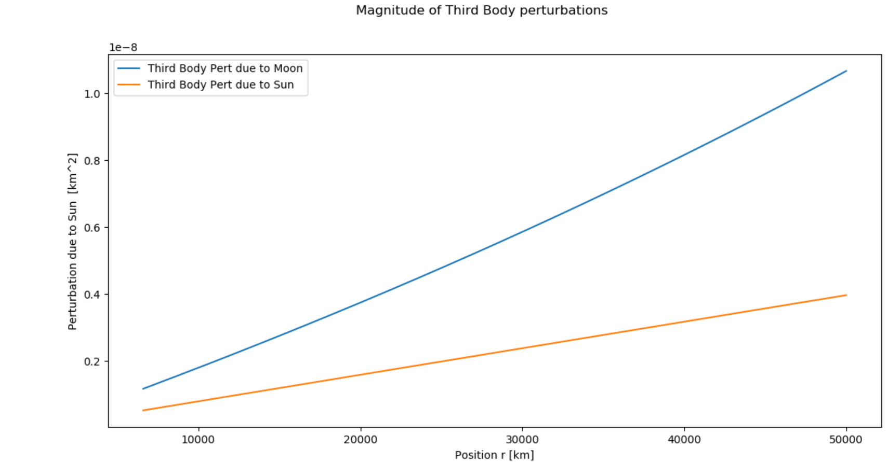
Problem 4
Problem 4a
Position in GCRF Frame [AU]: [[ 0.75780975 -0.57960912 -0.25126748]]
Problem 4b
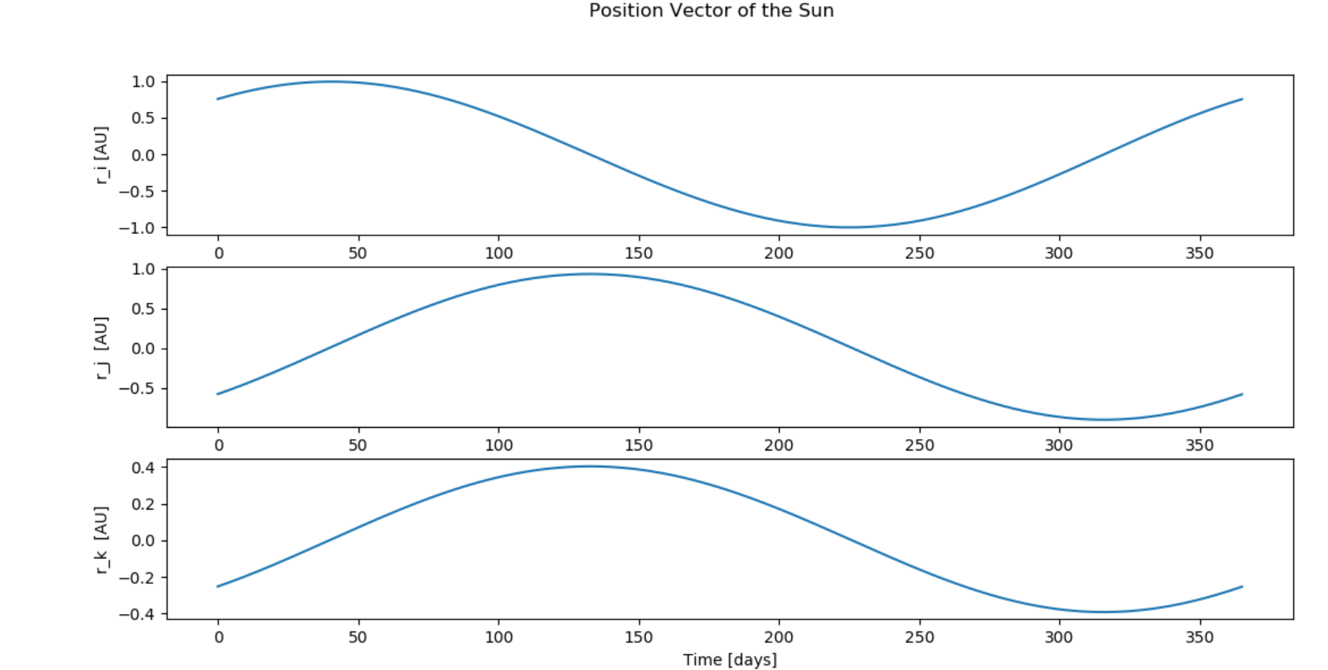

Problem 5
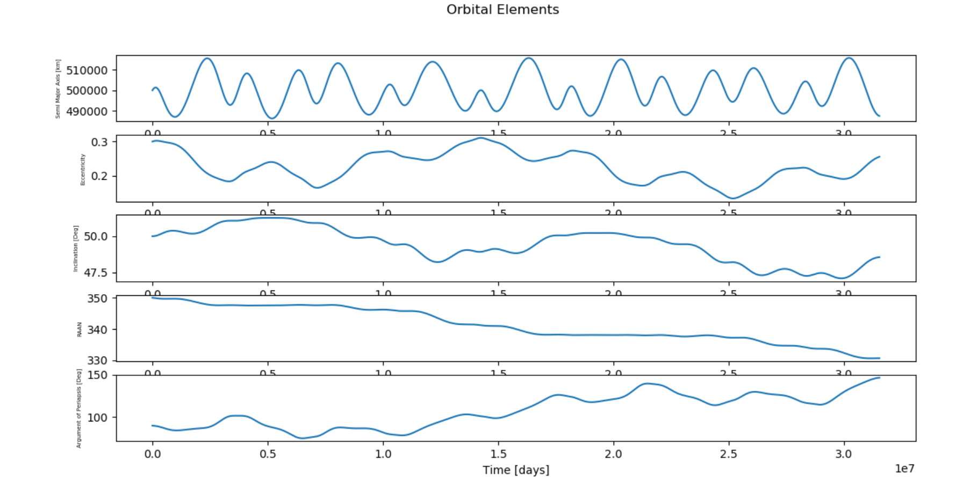
Yes! The changes in orbital elements match our expectations. Due to the perturbations of the sun, the orbit is changing in magnitude (as seen by the eccentricity and semi major axis). Based on our classroom discussions, the graphs above match our expectations that RAAN is changing. Due to the oblateness of the Earth, the force from the sun will exhibit a torque, thus causing the Earth’s khat vector to experience a precession.
Bonus Question
